Business Canvas
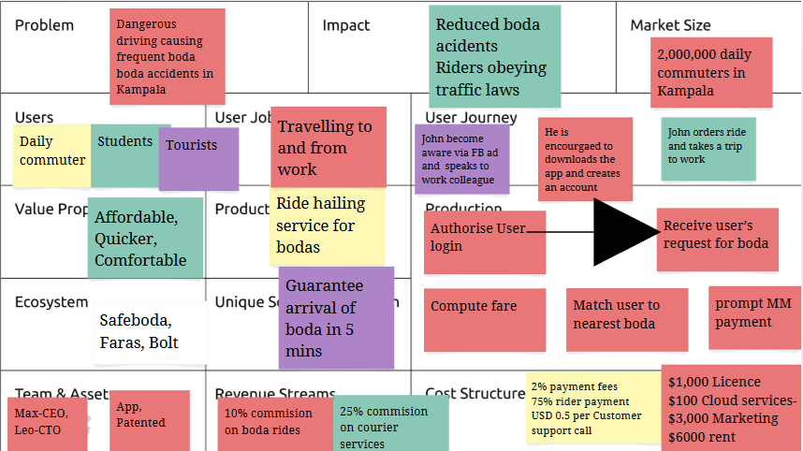

Problem
As COMMUTERS IN KAMPALA TRAVEL TO AND FROM WORK ON BODAS, they ARE STRESSED BY RECKLESS RIDING AND SUFFER FREQUENT ACCIDENTS. This problem affects 2,000,000 DAILY COMMUTERS IN KAMPALA.
AND $6m is spent by public hospitals to treat boda boda accident victims annually..
Solution
Our solution is THE MAX RIDE HAILING APP. It helps COMMUTERS IN KAMPALA TRAVEL TO AND FROM WORK ON BODAS more SAFELY, AFFORDABLY WITH PEACE OF MIND.
Scalability/Innovation
OTHER COMPANIES LIKE SAFE BODA AND UBER OFFER RIDE HAILING SERVICES ONLY IN KAMPALA, but our offering will be more ACCESSIBLE because WE SHALL EXTEND OUR SERVICES TO UPCOUNTRY TOWNS AND CITIES LIKE GULU, MBARARA, MBALE .
So, we could grow to reach ALL AREAS OF THE COUNTRY.

Business Model
We’ll sell each TRIP of THE MAX RIDE HAILING APP for $3
Each TRIP will cost us $1.9 to make, the cost breakdown being:
- Commission to rider - $1.4
- Google maps and software costs - $0.3
- Insurance - $0.2
Our monthly operations costs will total $350, from:
- Salaries: $300
- Rent:
- Online Marketing: $50
To get started, we’ll also have capital expenditure of $1500 on:
- Legal Registration - $500
- Computers- server - $1,000
- …
Social & Environmental Impact
Wider benefits of our solution’s use will be ROAD TRANSPORT SAFETY AND REDUCED TRAVEL TIME IN KAMPALA. We’ll measure these with:
- Key Performance Indicator 1: No of boda road accidents
- Key Performance Indicator 2: No of customer complaints about careless riding
- Key Performance Indicator 2: Average waiting time for boda and trips
Market Validation / Risk Mitigation
The biggest assumptions behind our venture model have been validated with the following 5+ prototyping tests:
- Describe the riskiest assumption; COMMUTERS ARE WILLING TO SPEND $3 PER KM
  - Describe the test and the results.
- Describe the 2nd most risky assumption; TOURISTS WOULD BE WILLING TO USE BODAS IN KAMPALA
  - Describe the test and the results. SPEAK TO 20 TOURISTS AND GET OPINIONS
- Describe the 3rd most risky assumption; GIRLS IN X-UGANDA CANT NOT ACCESS PADS
  - Describe the test and the results. 15/20 GIRLS SPOKEN TO SAID ….
- Describe the 4th most risky assumption; WE SHALL HAVE FULL REQUIREMENTS FOR THE LICENCE-CERTIFATE
  - Describe the test and the results. CHECKED WITH REGULATOR/ STANDARDS BODY AND GIVEN GO HEAD
Team
- MAX WEBER ASIIMWE, …, +25677773838838
  - CEO - MAX TRAVEL APP

- Name, Email, Phone
  - Role & Qualifications for Role
- …

Budget for Funding
We’ll use the $3,440 to cover the $1500 initial capital expenditure, and make 100 TRIP of THE MAX RIDE HAILING APP and cover 5 months of operations costs. The breakdown of the budget is:
Item Description | Cost | No. Units | Amount
Unit Costs  (Commission to rider - $1.4 Google maps and software costs - $0.3 Insurance - $0.2) | $1.9 | 100 | 190
Operations Costs  (Salaries: $400 Marketing: $200) | $350 | 5 | $1750
Capital Expenditure | $1500 | 1 | $1500
TOTAL

Goals
With $3,440, we’ll track performance against the following milestones/targets:
- Registration - We’ll register a company and open a bank account by [month].
- Product Design - Enhance the app by adding MM payments, …
- Production & Partnerships - …
- Sales - We’ll sell 100 TRIP of THE MAX RIDE HAILING APP in 5 months, generating $190 in revenue.
- …

